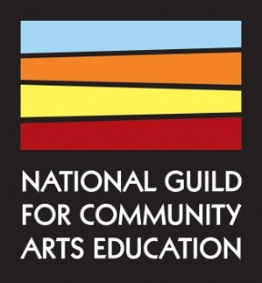
FOR OFFICE USE ONLY
Date rec’d:
Appeal:

Membership Application Form

Organization Name:

Please choose a membership category:

A Full Member is a tax-exempt organization or government agency, or division thereof, which offers arts learning opportunities and is committed to the values of quality, accessibility, and accountability.
☐ I certify that my organization subscribes to the National Guild’s philosophy (above) and code of best practices (page 4). Please initial:
☐ I have included proof of my organization’s tax-exempt status (i.e. IRS letter of determination sent along with this application to membership@nationalguild.org).

An Education Affiliate is a for-profit organization that offers arts learning opportunities.

Business Affiliate affords companies and organizations visibility and participation in the community arts education field.

An Individual Affiliate is an individual who supports the National Guild’s mission and values.
☐ Students: I have submitted a copy of my valid student I.D. from a 2-4 year college/university degree program.

Organizational Contact Information
The following information will be supplied to the public online.

Full Organization Name:
Address: City: State: ______ Zip:
Phone: Fax: General Email:
Website:
: : :
Other applicable social media platforms (e.g.: Instagram, YouTube, Pinterest, LinkedIn):

Organizational Description
The following information will be supplied to the public online (150 words).
Organizational Profile (For Full Members and Education Affiliates only)
Organizational role:
[Click here to select option]
Institution type (that best describes the structure of your independent institution or division)
[Click here to select option]
Year founded:
Primary disciplines offered:
☐ Dance ☐ Literary Arts ☐ Media Arts ☐ Music ☐ Theatre ☐ Visual Arts ☐ Not Applicable
Secondary disciplines offered:
☐ Dance ☐ Literary Arts ☐ Media Arts ☐ Music ☐ Theatre ☐ Visual Arts ☐ Not Applicable
Programs offered:

☐ Arts for Social Justice
☐ Arts in Correction/Juvenile Justice
☐ Arts in Education (K-12 schools)
☐ Arts Therapy
☐ Creative Aging (55+)
☐ Creative Placemaking
☐ Creative Youth Development
☐ Culturally Specific
☐ Early Childhood
☐ Individual/Group Instruction
☐ Pedagogical Training (Higher Ed)
☐ Performance Ensemble
☐ Pre-Professional
☐ Professional Development for Educators
☐ Special Needs

Primary Contact
The Primary Contact will be the main contact person from your organization whom both the National Guild and fellow members may contact regarding membership, questions about your organization, or collaboration efforts.
Primary Contact Name: Mr./Ms./Mrs./Dr.
Position:
Phone: ext. Email:
☐ Use other mailing address:

How did you hear about us?
☐ Referred by a current member. Individual name:
☐ Referred by my local arts agency
☐ Attended a Guild conference, webinar, or event. Name of Event: Year:
☐ Found the Guild website in a google search or through social media
Annual Membership Dues
Membership dues for Full and Education Affiliate members are based on the organization’s current year operating expenses. If your school or program is a division of an organization, university, or agency, please provide the annual operating expenses for your community arts education component only, not that of your parent organization.

Operating Expenses | Full/Education Affiliate |  | Business Affiliate:
$0 - $99,999 | $200 |  | $250/year
$100,000 - $199,999 | $300
$200,000 - $299,999 | $400
$300,000 - $399,999 | $440 |  | Individual Member:
$400,000 - $599,999 | $500 |  | - $100/year
$600,000 - $799,999 | $530 |  | - $30 students w/ valid student I.D.
$800,000 - $999,999 | $600
$1,000,000 - $1,199,999 | $660
$1,200,000 - $1,499,999 | $1,000
$1,500,000 - $1,999,999 | $1,200
$2 million - $2,999,999 | $1,500
$3 million - $3,999,999 | $2,000
$4 million and up | $2,500

My organization’s (or division’s) current year operating expenses are $

☐ I am eligible for a promotional discount on membership dues named:
Annual Dues: $ .00
Promotion/Discount: $ .00
TOTAL: $ .00
Method of payment:
☐ Check or Money Order (Make checks payable to “National Guild”)
☐ ☐ 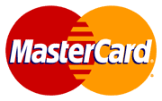 ☐ ☐
Acct.# Expiration Date: _____ / _____ Sec. Code:
Cardholder Name:
Billing Address: City: State: ______ Zip:
Cardholder's Signature: Date:

Please email, mail or fax this form with appropriate attachments and dues to:
National Guild for Community Arts Education
ATTN: RANGSEY kEO, MEMBERSHIP & OPERATIONS COORDINATOR
Email: membership@nationalguild.org
Fax: (212) 268-3995
Mail: 520 8th Avenue, Suite 302, New York, NY 10018
Questions? Email membership@nationalguild.org or call (212) 268-3337 ext. 20.
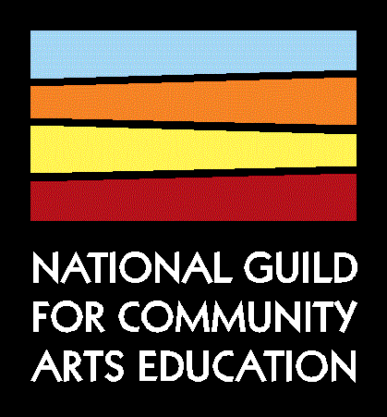

CODE OF BEST PRACTICES
Full members of the National Guild are committed to

QUALITY | ACCESSIBILITY | ACCOUNTABILITY
- by offering broad, sequential programming that is responsive to community needs and reflects their organization’s mission  - by challenging each student to realize his/her highest level of artistic potential  - by affording students the opportunity to participate in recitals, presentations, publications, workshops and/or exhibitions  - by engaging a qualified faculty  - by utilizing an appropriately equipped instructional facility | - by serving students regardless of age, sex, gender, race, religion, national and ethnic origin, sexual orientation, ability, or financial circumstances  - by eliminating physical and communication barriers that prevent people with disabilities from participating fully in their programs  - by offering need-based financial aid and/or other subsidized arts education programs  - through administrative and hiring policies that do not discriminate on the basis of age, sex, gender, race, religion, national and ethnic origin, sexual orientation, or disability | - by sustaining and monitoring their mission and service to the community  - by effective management with professional staff  - through governance by a body such as a board of directors that ensures accountability, adherence to mission, and responsiveness to community  - by adhering to policies and procedures that ensure the safety and security of students, faculty and staff

THE NATIONAL GUILD SUPPORTS AND ADVANCES LIFELONG LEARNING OPPORTUNITIES IN THE ARTS

© 2006, NATIONAL GUILD | WWW.NATIONALGUILD.ORG

